Low Level Design



Analyzing world's best wine reviews dataset

REVISION NO-1.2

LAST DATE OF REVISION-16.02.2025

KASHISH MALVIYA

DOCUMENT CONTROL

|  |  |  |  |
| --- | --- | --- | --- |
| Date | Version | Description | Author |
| 15.02.2025 | 1.0 | Introduction,Problem statement | Kashish |
| 16.02.2025 | 1.1 | Database information,architecture  description | Kashish |
|  | 1.2 | Final revision | Kashish |

Contents

1. Introduction............................................................

1.1 What is Low-Level Design Document? ..........................................

1.2 Scope..........................................................................

1.3 Project introduction..........................................

2.problem statement

3. Dataset Information

4. Architecture

4.1 Architecture Description...............................

**1. Introduction**

**1.1 What is Low-Level design document?**

The goal of the LDD or Low-level design document (LLDD) is to give the internal logic design of the actual program code for the House Price Prediction dashboard. LDD describes the class diagrams with the methods and relations between classes and programs specs. It describes the modules so that the programmer can directly code the program from the document.

**1.2 Scope**

Low-level design (LLD) is a component-level design process that follows a step-by-step refinement process. The process can be used for designing data structures, required software architecture, source code and ultimately, performance algorithms. Overall, the data organization may be defined during requirement analysis and then refined during data design work.

**PROJECT INTRODUCTION:**

The dataset describes the amount of various chemicals present in wine and their effect on it's quality. The datasets can be viewed as classification or regression tasks. The classes are ordered and not balanced (e.g. there are much more normal wines than excellent or poor ones).

**DATA INFORMATION:**

**1.Country:** The country of origin

**2.Price** : Price of the wine

**3.Points**: Wine rating (score)

**4.Variety:** Type of grape used

**5. Provience:** The region within the country

**6.Winery**: Name of the winery

7**.Description:** Text review of the wine

**8.Designation, region_1,region_2:** Additional location details

**Architecture**

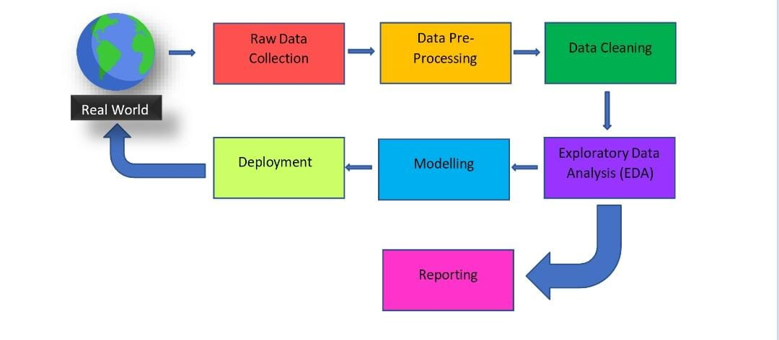

**Architecture Description:**

**1. Raw Data Collection**

The Dataset was taken KAGGLE website.

Document

https://www.kaggle.com/datasets/zynicide/wine-reviews

**2. Data Pre-Processing**

Before building any model, it is crucial to perform data pre-processing to feed the correct data to the model to learn and predict. Model performance depends on the quality of data feeded to the model to train.

This Process includes:

a) Handling Null/Missing Values

b) Handling Skewed Data

c) Outliers Detection and Removal

**3. Data Cleaning**

Data cleaning is the process of fixing or removing incorrect, corrupted, Incorrectly formatted, duplicate, or incomplete data within a dataset.

a) Remove duplicate or irrelevant observations

b) Filter unwanted outliers.

c) Renaming required attributes

4. Exploratory Data Analysis (EDA)

Exploratory Data Analysis refers to the critical process of performing initial investigations on data to discover patterns, spot anomalies, test hypothesis and to check assumptions with the help of summary statistics and graphical representations.

**5. Reporting**

Reporting is a most important and underrated skill of a data analytics field. Because being a Data Analyst you should be good in easy and self-explanatory report because your model will be used by many stakeholders. who are not from technical background.

a) High Level Design Document (HLD)

b) Low Level Design Document (LLD)

c) Architecture

d) Wireframe

e) Detailed Project Report

f) Power Point Presentation

**6. Modelling**

Data Modelling is the process of analysing the data objects and their relationship to the other objects. It is used to analyse the data requirements that are required for the business processes. The data models are created for the data to be stored in a database. The Data Model's main focus is on what data is needed and how we have to organize data rather than what operations we have to perform.

**7. Deployment**

We created a Power BI Dashboard

**World Wine data analysis Report of 2017**

